How to Draw Pirate Ships
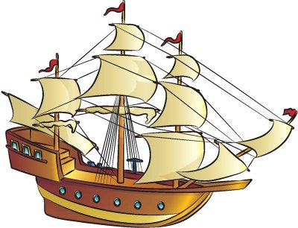
Ahoy, mateys! Use the easy instructions on this page to draw your own pirate ship, in the Caribbean or elsewhere.

In this section, we'll show you how to draw the above pirate ship. Either draw it freehand while looking at your computer monitor or print out this page to get a closer look at each step.

Follow the red lines in each illustration to learn exactly what to draw in that step. The lines drawn in previous steps are shown in gray. Here, we'll show you an illustration of each step and then give you a description of how to draw it.

How to Draw Pirate Ships: Draw the body of the pirate ship.

Step 1: Draw the long, triangular main form for the boat.
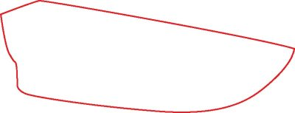
How to Draw Pirate Ships: Add details to the deck of the boat.

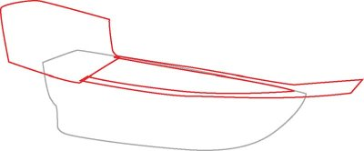
Step 2: Add an angled shape on the back end of the boat. Draw a line along the side of the boat, and continue it on to form a post coming off the front end of the ship. Bring the line back along the far side of the hull.

How to Draw Pirate Ships: Outline the top structures to add depth.
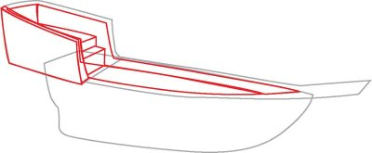

Step 3: Outline the back shape and the top of the boat's hull to add depth and create the ship's deck. Use stacked rectangles to add details to the back deck and deck steps.

How to Draw Pirate Ships: Draw three tall masts.

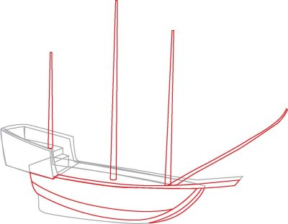
Step 4: Draw three tall masts rising from the deck. Add a fourth mast angling forward from the deck. Draw a long, curved bar that extends to the end of the post on the boat's tip. Use lines to sketch some side beam details on the hull.

How to Draw Pirate Ships: Add crossbars to the masts and portholes to the side of the ship.

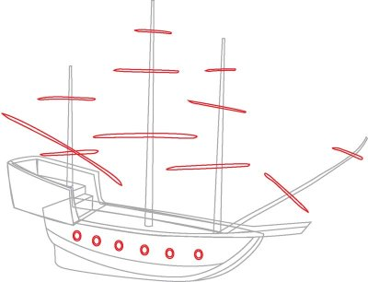
Step 5: Sketch long, thin sticks on the masts to create the crossbars. Add six circular porthole windows on the boat's side.

How to Draw Pirate Ships: Add flags to the masts and details to the ship.

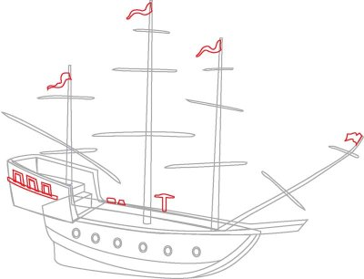
Step 6: Draw three rectangular windows on the back of the ship. Add a long, thin rectangle underneath them to create detail. Sketch flags on each mast. Draw two small wedges and a shape like a pickax on the far side of the deck.

How to Draw Pirate Ships: Draw sails.

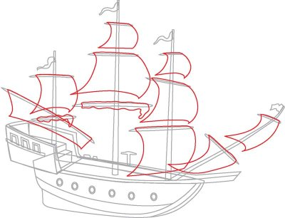
Step 7: Draw sails using the crossbars and masts as guides. The lowest sails on the back two masts are rolled up on the crossbars. To create this look, draw a squiggly-lined rectangular shape.

How to Draw Pirate Ships: Add lines between the sails.

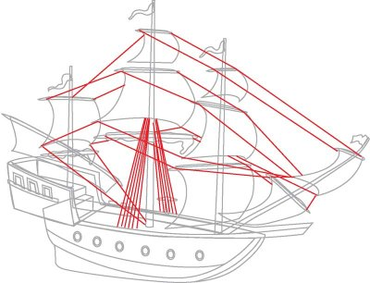
Step 8: Draw lines going from one crossbar to another. Add several lines angling down from the center mast.

How to Draw Pirate Ships: Trace the final drawing with a felt-tip pen.

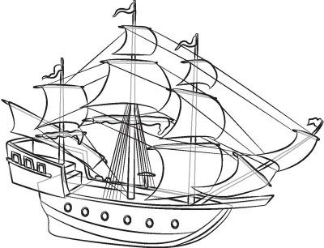
Step 9: Trace the pencil lines you want to keep with a felt-tip pen. Erase any extra lines.

Draw a day at the lake with water skiing or maybe a swift race around an aquatic track with our next drawing project.

